# **209 Seafloor Spreading**

## *Harry Hess and Seafloor Spreading Notes*

# **Warm-up:**

## Q:

## A:

# **Harry Hess Video**

## What is Harry Hess’s background?

## Before WWII, what did scientists think the ocean floor looked like?

## What tool was used to discover the Mid-Atlantic Ridge?

## What happens to the age of the sea-floor the further it is from the Mid-Atlantic Ridge?

## What did Hess call his great discovery?

## Why doesn’t the earth get any bigger if the sea-floor continues to expand and grow?

# **Harry Hess was a:**

# __________ & __________ __________

## Suggested that the seafloor is _______________ at the _________________:

### Magma …

### New seafloor…

### This could be the “reasoning” or mechanism Wegener was looking for…

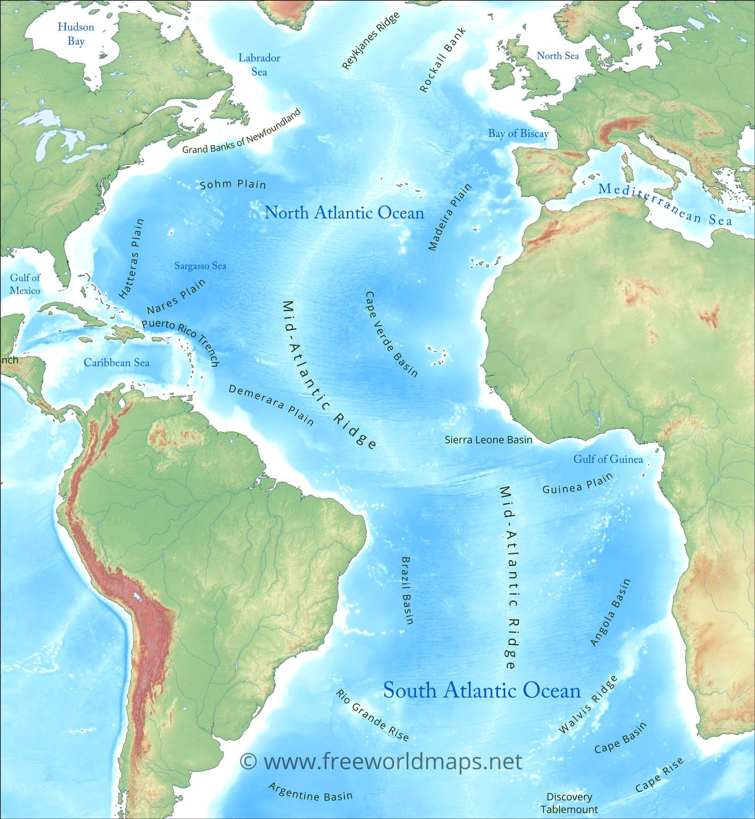

# **Seafloor Spreading**

## **Mid-Atlantic Ridge:**

**!!** Trace the Ridge on Figure 1 🡺

## Scientists…

## Found that the rocks were:

### ____________near the ___________ , and

### ____________near the ____________

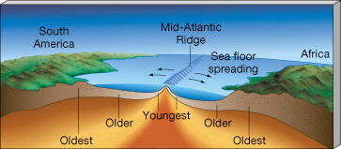

# Earth’s Magnetic Field

## Generated …

## Earth's ______ ______ core churns a ______ ______core

### Core is made of ____________ & ___________

### 

### 

### And…

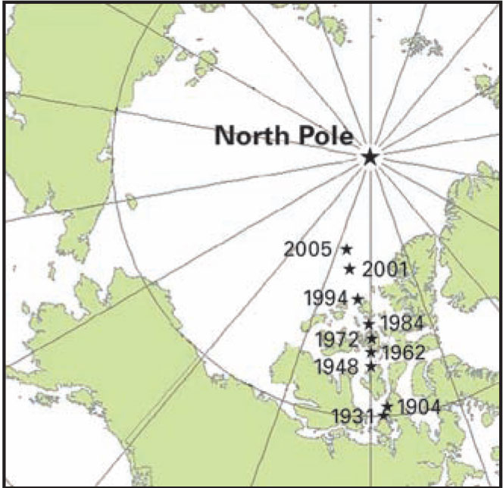

# Earth’s Poles Reverse:

## The magnetic poles …

## The poles ___________ every ____________________________.

# **Paleomagnetism:** Proving the Earth’s Magnetic Field Reverses with **EVIDENCE**

## 

## When lava cools, …

## 

Add arrows showing the orientation of the magnetic field for each “stripe”

